What is a Higher-Order Function?

https://medium.com/@dineshsuthar03/mastering-higher-order-functions-in-python-e6fb67a0fcd5
https://www.youtube.com/watch?v=lkbgOf1jD8k&list=PLsyeobzWxl7omDoEYrrf3oXvXxa6MPgek&index=34
https://medium.com/@swami.learnovate/superpowers-of-python-functions-first-class-higher-order-explained-2daa43969b3c

First-Class Citizens (Functional Programming)
In languages like Java or C++, objects or primitive data types are the main focus. However, Python supports Functional Programming, meaning functions are treated as first-class citizens.
Being a first-class citizen means a function can do anything a regular variable or object can do:
- It can be stored inside a variable.
- It can be passed as an argument to another function.
- It can be returned from another function.
- It behaves like an object behind the scenes.

What makes a function "Higher-Order"?
A standard function takes values (like integers or strings) and returns a value.
A Higher-Order Function (HOF) is a function that operates on other functions. It must meet at least one of these two conditions:
- It accepts a function as one of its parameters.
- It returns a function as its output.

In Python, functions are First-Class Citizens. This means functions can be treated just like any other data type (such as integers, strings, or lists) [00:05:25]. Because of this flexibility:
- You can assign functions to variables.
- You can pass functions as parameters (arguments) to other functions [00:00:35].
- You can return functions from other functions.
A Higher-Order Function (HOF) is specifically a function that accepts another function as an argument or returns a function as its result

2. Basic Example: Single Value Operation
Let's start with a foundational example. Imagine you want a general-purpose processor machine called operate. You feed it a number and a specific "action tool" (like a squaring tool or a cubing tool), and it processes the number using that exact tool.
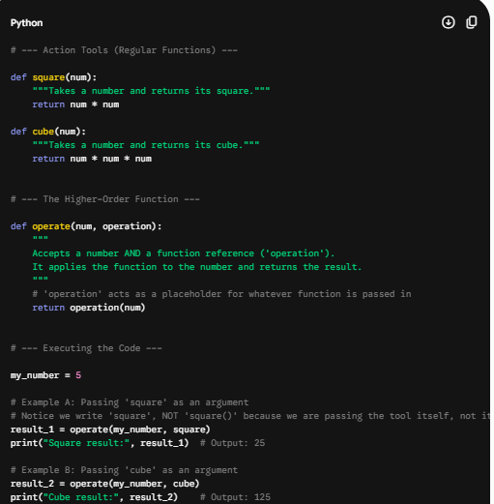

Code Walkthrough & Line Explanation
- Defining Tools (square and cube): These are normal, basic functions that expect one numeric value.
- The Higher-Order Wrapper (operate): Look closely at the parameters: def operate(num, operation):. The parameter named operation is designed to hold a function reference.
- Dynamic Execution: Inside the function, operation(num) runs. If you sent square into the machine, it dynamically morphs into square(num). If you sent cube, it morphs into cube(num).
- The Function Calls: When calling operate(my_number, square), we pass square without parenthesis. Adding parenthesis square() calls the function immediately. Leaving them off passes the function's identity as data.

3. Practical Example: Processing Collections (Lists)
Higher-order functions show their true strength when you need to apply different rules to groups of data dynamically. Instead of creating multiple complex loops, you create one loop structure that accepts the processing rule from the outside.

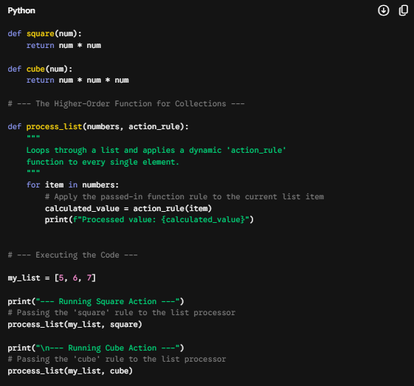
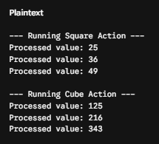

Code Walkthrough & Line Explanation
- process_list(my_list, square): Python passes the structure of your list and the formula mapping of square into process_list.
- The Loop Structure: Inside process_list, the code pulls out the first number (5). It then triggers action_rule(5), which executes the code inside square(5) yielding 25.
- The Benefit: If tomorrow you want to create an absolute_value function or a double_the_number function, you do not need to modify the loop code inside process_list. You simply write your new small tool and pass it right in.

4. Summary of Key Takeaways
- No Parentheses When Passing: Always pass the function name as a variable (square), not as an executed function (square()).
- Code Reusability: Higher-order functions stop code duplication. You separate the execution wrapper logic (loops, data reading, validation) from the actual math or manipulation formula.
- Flexibility: They let Python act seamlessly across object-oriented patterns and clean, mathematical functional programming workflows.

